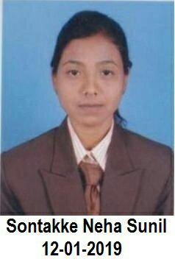neha s. sontakke

Email: - nehasontakke123@gmail.com

Contact: - 8767245367, 9168786962

Address: At Ramji Ambedkar Nagar, 8Th Mile Amravati Road Nagpur (440023)

DOB: - 20 OCT 1997

Objectives

Develop engineering analysis capabilities in the domain and perform up to the satisfaction of my seniors and superior to improve work efficiency.

Education

**BHIDE GIRL’S HIGH SCHOOL AND JR. COLLEGE NAGPUR**

* Maharashtra State Board (10th) - [68.60%] 2013
* Maharashtra State Board (12th) - [54.46%]2015

**G.H.RAISONI POLYTECHNIC COLLEGE OF NAGPUR**

* Maharashtra State Board Of Technical Education (Diploma) 2018

(Electronics and Telecommunication Engineering) - [68.29%]

**ST. VINCENT PALLOTTI COLLEGE OF ENGINEERING AND TEHNOLOGY NAGPUR**

* (BE In Electronics And Telecommunication Engineering )

[8.31 SGPA] 2021

Experience

* **Fresher**

**Skills**

* **Technical Skills :** MS-CIT , MS-OFFICE, TALLY ERP 9.0 , ENGLISH TYPEWRITING [SPEED W.P.M. 30,40] , MARATHI TYPEWRITING [SPEED W.P.M. 30]
* **Soft skills:**
* Teamwork and Leadership
* Confidence
* Interpersonal skills

**PROJECT**

1. “DISTANCE TO FUEL METER”.
2. “GUI Based Error Correction In Data Communication Using MATLAB”
3. “AUTOMATIC ROOM LIGHT CONTROLLER BY USING ARDUINO AND SENSOR”.

**INTERNSHIP**

* Electric Loco Shed Ajani , Nagpur
* Python Programming

**STRENGTH**

* Responsible
* Hardworking
* Disciplined
* Self-Learner

**CERTIFICATION**

* VLSI Design Using Verilog HDL- Workshop.
* Soft Skill Training for Barclays organized by Global Talent Track.
* Quizonix-2018
* Antenna Designing and Fabrication (CYRONICS INSTRUMENTS PVT.LTD.)

Place: Your’ Faithfully

Nagpur Neha S. Sontakke